Creating Microservices for account and loan
Accounts
AccountController.java
package com.cognizant.account.controller;

import org.springframework.web.bind.annotation.*;

import java.util.HashMap;
import java.util.Map;

@RestController
@RequestMapping("/accounts")
public class AccountController {

@GetMapping("/{number}")
public Map<String, Object> getAccount(@PathVariable String number) {
Map<String, Object> response = new HashMap<>();
response.put("number", number);
response.put("type", "savings");
response.put("balance", 234343);
return response;
}
}
AccountApplication.java
package com.cognizant.account;

import org.springframework.boot.SpringApplication;
import org.springframework.boot.autoconfigure.SpringBootApplication;

@SpringBootApplication
public class AccountApplication {

public static void main(String[] args) {
SpringApplication.run(AccountApplication.class, args);
}

}
Output :
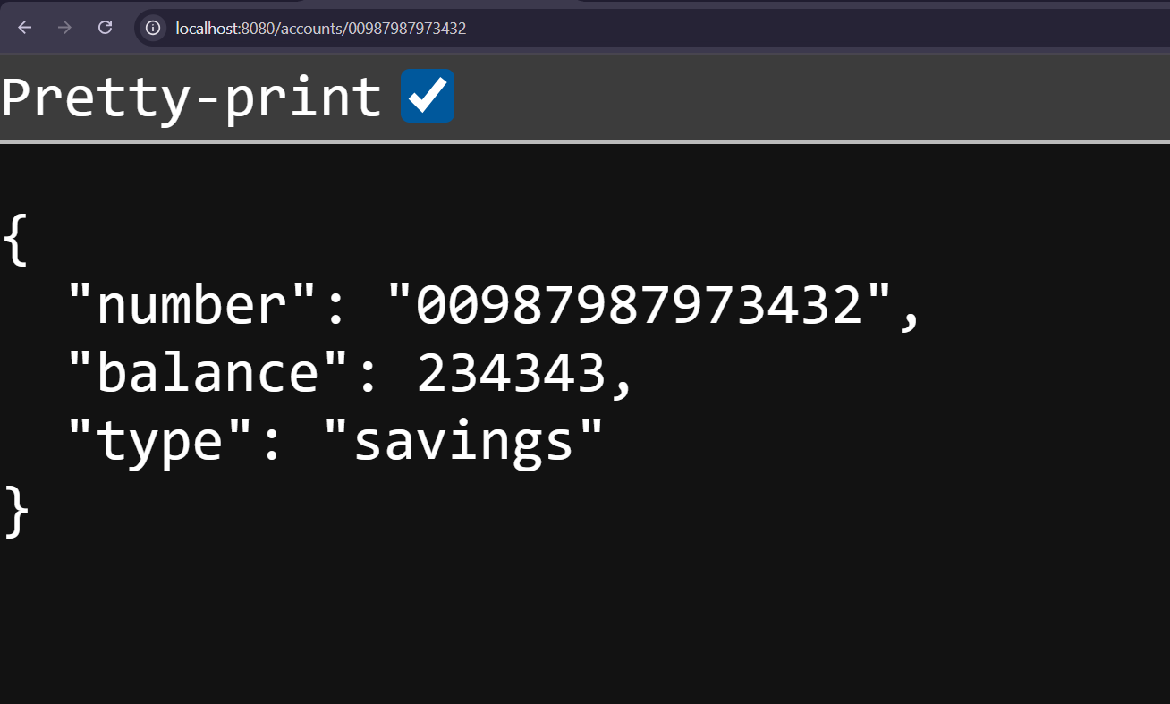

Loans
LoanController.java
package com.cognizant.loan.controller;

import org.springframework.web.bind.annotation.*;

import java.util.HashMap;
import java.util.Map;

@RestController
@RequestMapping("/loans")
public class LoanController {

@GetMapping("/{number}")
public Map<String, Object> getLoan(@PathVariable String number) {
Map<String, Object> response = new HashMap<>();
response.put("number", number);
response.put("type", "car");
response.put("loan", 400000);
response.put("emi", 3258);
response.put("tenure", 18);
return response;
}
}
LoanApplication.java
package com.cognizant.loan;

import org.springframework.boot.SpringApplication;
import org.springframework.boot.autoconfigure.SpringBootApplication;

@SpringBootApplication
public class LoanApplication {

public static void main(String[] args) {
SpringApplication.run(LoanApplication.class, args);
}

}

Output : 